**BOND MATURITY DATE COMPUTATION**

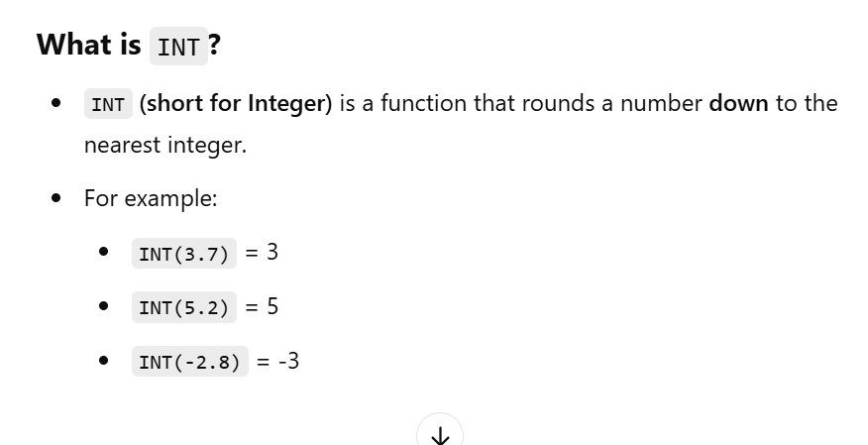

**Problem01 : Computing the Maturity Date for a Bond**

XYZ Finance Ltd. issued a bond, Bond A, with the following details:

1. Settlement Date: February 15, 2017
2. Term of the Bond: 10.50 years

The company needs to calculate the Maturity Date of the bond.

**Problem 2: Computing the Maturity Date for a Bond**

DEF Finance Ltd. issued a bond, **Bond B**, with the following details:

1. **Settlement Date**: March 30, 2024
2. **Term of the Bond**: 5.27 years

The company needs to calculate the **Maturity Date** of the bond.

**Problem 3: Computing the Maturity Date for a Bond**

**XYZ Finance Ltd. issued a bond, Bond I, with the following details:**

1. **Settlement Date: November 12, 2022**
2. **Term of the Bond: 15.35 years**

**The company needs to calculate the Maturity Date of the bond.**

**Problem 4: Computing the Maturity Date for a Bond**

**DEF Finance Ltd. issued a bond, Bond J, with the following details:**

1. **Settlement Date: June 10, 2024**
2. **Term of the Bond: 20.50 years**

**The company needs to calculate the Maturity Date of the bond.**

**Problem 5: Computing the Maturity Date for a Bond**

GHI Finance Ltd. issued a bond, **Bond C**, with the following details:

1. **Settlement Date**: July 20, 2021
2. **Term of the Bond**: 6.25 years

The company needs to calculate the **Maturity Date** of the bond.

**Problem 6: Computing the Maturity Date for a Bond**

JKL Finance Ltd. issued a bond, **Bond D**, with the following details:

1. **Settlement Date**: March 15, 2024
2. **Term of the Bond**: 5.50 years

The company needs to calculate the **Maturity Date** of the bond.

**Problem 7: Computing the Maturity Date for a Bond**

MNO Finance Ltd. issued a bond, **Bond E**, with the following details:

1. **Settlement Date**: April 20, 2023
2. **Term of the Bond**: 8.25 years

The company needs to calculate the **Maturity Date** of the bond.

**Problem 8: Computing the Maturity Date for a Bond**

PQR Finance Ltd. issued a bond, **Bond F**, with the following details:

1. **Settlement Date**: August 5, 2024
2. **Term of the Bond**: 7.25 years

The company needs to calculate the **Maturity Date** of the bond.

**Problem 9: Computing the Maturity Date for a Bond**

STU Finance Ltd. issued a bond, **Bond G**, with the following details:

1. **Settlement Date**: October 14, 2022
2. **Term of the Bond**: 9.30 years

The company needs to calculate the **Maturity Date** of the bond.

**Problem 10: Computing the Maturity Date for a Bond**

VWX Finance Ltd. issued a bond, **Bond H**, with the following details:

1. **Settlement Date**: May 20, 2023
2. **Term of the Bond**: 7.50 years

The company needs to calculate the **Maturity Date** of the bond.